|  |  |
| --- | --- |
|  | |
|  | |
|  |  |

|  |  |
| --- | --- |
| Publication type: |  |
| Publication number: |  |
| Title: |  |
| Subject: |  |
| Issue: | 1.2.10 |
| Publication date: |  |
| Total number of pages: |  |
| Author: |  |
| Quality Control: |  |

Table of contents

Page #

2. Figures 4

3. Tables 4

4. References 6

5. Introduction 7

6. Safety instructions 9

7. Revision history 9

8. Workstations and panels 10

8.1 Introduction 10

8.2 Workstations 11

8.3 DAP 12

8.4 Alarm panels 13

8.4.1 BNWAS Bridge 14

8.4.2 BNWAS Cabin 15

8.4.3 BNWAS Cabin mini 15

8.5 AMS Bridge 16

8.5.1 Entrance ER 17

8.5.2 AMS Cabin 18

8.5.3 BNWAS-AMS Combi 19

9. Alarm Matrix 20

9.1 Introduction 20

9.2 The matrix 20

9.2.1.1 This station 21

9.2.1.2 Is fallback for 21

9.2.1.3 Show all alarm stations 21

9.2.1.4 Alarm group rights/Duty alarm rights 21

9.2.1.5 Adjustments 21

9.2.1.6 How to set Alarm Group Rights 22

9.3 Background 24

10. Appendix I 25

10.1 Rules concerning Deadman Systems 25

10.2 BNWAS or Bridge Deadman 25

10.2.1 Scope 25

10.2.2 The BNWAS should incorporate the following operational modes: 25

10.2.3 Operational sequence of indications and alarms 25

10.2.3.1 Operational State 25

10.2.3.2 Reset function 26

10.2.3.3 Emergency call facility 26

10.2.3.4 Security 26

10.2.3.5 Malfunction 26

10.3 Engineer Deadman 26

10.3.1 Scope 26

10.3.2 The Engineer Deadman System should incorporate the following operational modes: 27

10.3.3 Operational sequence of indications and alarms 27

10.3.3.1 Operational State 27

10.3.3.2 Reset function 27

10.3.3.3 Emergency call facility 27

10.3.3.4 Security 27

10.3.3.5 Malfunction 28

Figures

Figure 8‑1: Alarm screen Workstation 10

Figure 8‑2: Duty Alarm Panel 11

Figure 8‑3: Alarm Panel (Typical) 11

Figure 8‑4: Station Setting 12

Figure 8‑5: Engine room duty button 12

Figure 8‑6: Bridge (backup) duty button 12

Figure 8‑7: DAP screen 13

Figure 8‑8: DAP configuration 13

Figure 9‑1: Station Matrix 20

Figure 9‑2: Alarm station settings 22

Figure 9‑3: Select by dragging 22

Figure 9‑4: Duty Select function 23

Figure 9‑5: Call Select function 24

Tables

Table 9‑1: Alarm Group Rights 21

Table 9‑2: Duty Alarm Rights 23

**NOTICE**

**This document contains proprietary information.**

**No part of this document may be photocopied, reproduced or translated into another language without the prior written consent of   
Free Technics B.V.**

References

[A] NavVision-Operator-Manual-v1.3

[B] NavVision Software installation and commissioning manual v1.9

Introduction

The duty selection and the alarm configuration is a basic part of FT NavVision®. It is of such importance that this manual is dedicated to this specific item. It will also be covered in the “Operator manual” and the “Software installation and commissioning manual”.

The basics of the FT NavVision© duty and alarm system are the workstations, the alarm-panels and the alarm matrix. The first two are the physical stations that are placed along the ship in the specific spaces. The last one is the matrix under settings where you define where alarms will show, who is on duty (as well for the ER and the Bridge), who can do what with the alarms etc.

Chapter 8 will first discuss the different kind of panels there are, so you know where to place which panel. After that chapter 9 will show you how to configure the matrix for different circumstances.

Abbreviations list

BNWAS Bridge Navigational Watch Alarm System

ER Engine Room

OOW Officer On Watch

Safety instructions

*:  
This section provides only a summary of the most important safety requirements and notes, which will be mentioned in the individual sections. To protect your health and prevent damage to the devices, it is essential to read and carefully follow the safety instructions.*

The indications NOTE, CAUTION and WARNING have the following significance:

*NOTE:  
An operating procedure, practice or condition etc., which it is essential to emphasize.*

**CAUTION**

**An operating procedure, practise or condition etc., which, if not strictly observed, may damage or destroy equipment.**

**WARNING**

**An operating procedure, practise or condition etc., which, if not carefully observed may result in personal injury or loss of life.**

Revision history

Revisions issued since publication.

|  |  |  |  |
| --- | --- | --- | --- |
| **Issue** | **Date** | **Revision** | **Reason** |
| 1.0 | March 11, 2013 |  | initial release |
| 1.1 | March 13, 2013 | Extension | New issues |
| 1.2.10 | August 23, 2013 | Fixes and overhaul | Imtech |

# Workstations and panels

## Introduction

Each FT NavVision© system consists of at least two full workstations. Mostly they are situated in the Wheelhouse and in the Engine room. These workstations, also called servers, will have the alarm screen with duty selection. When you click on the alarm icon in the taskbar it will show the “duty and Alarm mimic” (see Figure 8‑1).

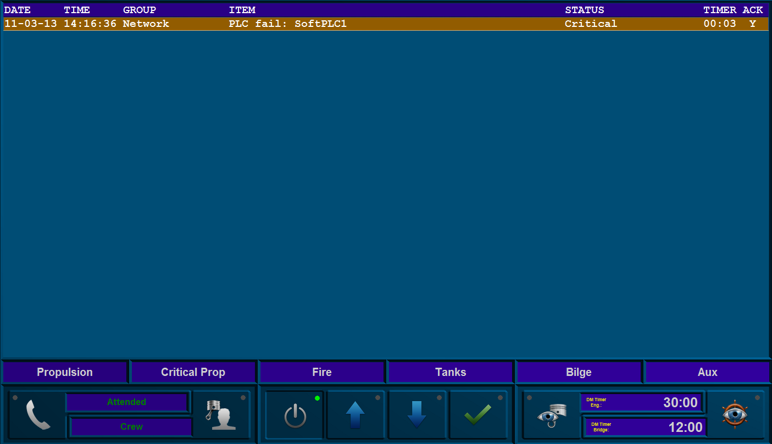

Figure 8‑1: Alarm screen Workstation

In smaller spaces FT NavVision© often use DAP’s (Duty Alarm Panels) which can be used to see and act upon alarms (see Figure 8‑2). These DAP’s have less functionality than a normal workstation. They are solely meant to show the alarms on an active panel. It is possible to determine which alarms will show here in the Alarm Matrix.

In a mess room and other public spaces workstations that are configured as client can be used so you can also see mimics etc. (see Figure 8‑1).

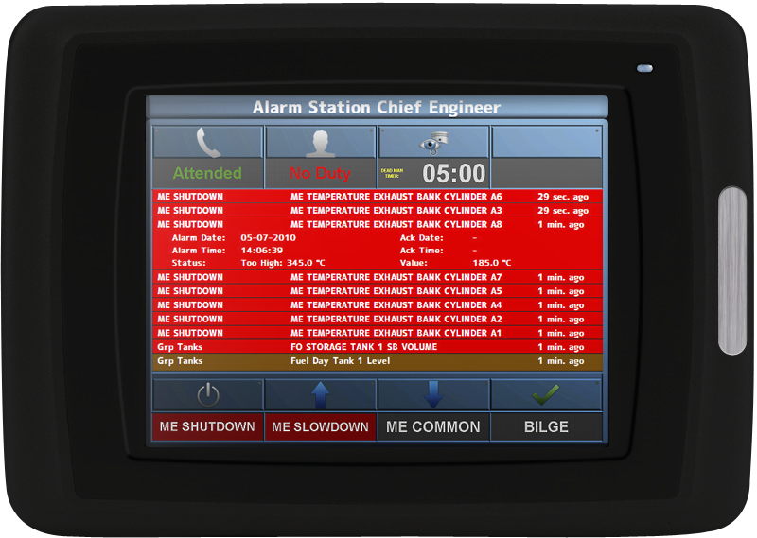

Figure 8‑2: Duty Alarm Panel

If we don’t need a workstation and a DAP is still too big or too expensive, FT NavVision© can place an Alarm Panel. These Alarm Panels are metal plates accommodated with different kinds of buttons and most likely a buzzer (see Figure 8‑3).

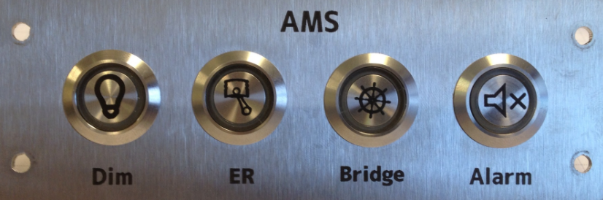

Figure 8‑3: Alarm Panel (Typical)

## Workstations

Workstations are well described in the other manuals such as the Operator Manual. We just like to stress out that you can have the alarm mimic respond to which station you set it to. In the Matrix you can choose which station the mimic must represent (see Figure 8‑4). Also it is possible that it will serve as a fallback for another station.

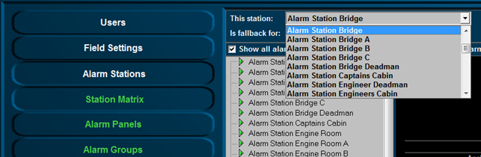

Figure 8‑4: Station Setting

At the duty-select button you can see if it is a station for the Engine room duty (see Figure 8‑5) or the Bridge (backup) duty (see Figure 8‑6).



Figure 8‑5: Engine room duty button



Figure 8‑6: Bridge (backup) duty button

Other than setting the station, you do not have to configure anything here. The configuration depends on the Matrix which will be discussed later.

## DAP

For the DAP’s (see Figure 8‑7) it is practically the same as for the workstation. The only difference is that you will have to set the station selection of a DAP on a server under Alarm Stations/Alarm Panels (see Figure 8‑8). For the rest it will be the same as the alarm screen of a workstation and it will depend on the Matrix that we discuss later.

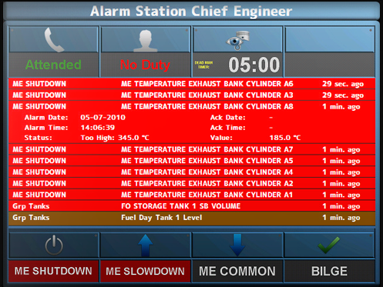

Figure 8‑7: DAP screen

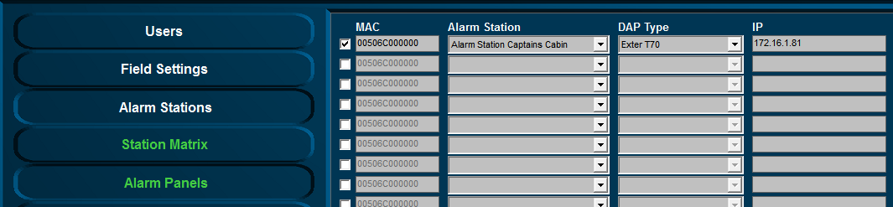

Figure 8‑8: DAP configuration

## Alarm panels

As explained before, Alarm panels are metal plates with buttons and a buzzer. These panels can be placed in different locations. These are simplified systems to represent the alarm mimics on a workstation or a DAP. These panels can be configured in many ways, depending on what you want to do with it. Is it just an alarm panel then it probably has only one button and a buzzer. Is it also a duty panel, then it will be 3 or 4 buttons.

We will show you here the most commonly used panels with the explanation of what they do. Together with the right FT NavVision© field tag you can configure them for all different occasions.

### BNWAS Bridge

|  |  |
| --- | --- |
| Panel horizontal-vertical | |
|  | |
|  | |
| Location of use: | Main Bridge |

|  |  |  |  |
| --- | --- | --- | --- |
| Button | Color | Function | FT NavVision© Field (Button/Led) |
| Dim | Blue | Dim panel lights* | Station Bridge Deadman Panel Dim Switch |
| Station Bridge Deadman Panel Dim LED |
| Timer | Green | Reset timer  Illuminates when active | Station Bridge Timer Reset |
| Station Bridge Timer Active LED |
| Alarm | Red | Alarm silence** | Station Bridge Deadman Silence |
| Station Bridge Deadman Alarm Active LED |
| Buzzer |  | Alarm*** | Station Bridge Deadman Alarm Buzzer |

### BNWAS Cabin

|  |  |
| --- | --- |
| Panel horizontal-vertical | |
|  | |
|  | |
| Location of use: | Crew cabins that can be selected for bridge duty |

|  |  |  |  |
| --- | --- | --- | --- |
| Button | Color | Function | FT NavVision© Field (Button/Led) |
| Dim | Blue | Dim panel lights* | Station (Captains Cabin) Panel Dim Switch |
| Station (Captains Cabin) Panel Dim LED |
| Bridge | Green | Bridge deadman Select, illuminates when active | Crew Alarms: Bridge: (Captain) On Duty |
| Station (Captains Cabin) Bridge On Duty LED |
| Alarm | Red | Alarm silence** | Station Bridge Deadman Silence |
| Station Bridge Deadman Alarm Active LED |
| Buzzer |  | Alarm*** | Station Bridge Deadman Alarm Buzzer |

### BNWAS Cabin mini

|  |  |
| --- | --- |
| Panel horizontal-vertical | |
|  | |
|  | |
| Location of use: | All spaces where Bridge duty crew can be available (no duty select) |

|  |  |  |  |
| --- | --- | --- | --- |
| Button | Color | Function | FT NavVision© Field (Button/Led) |
| BNWAS | Red | Bridge duty and timer reset | Button has no function |
| Station Bridge Deadman Alarm Active LED |
| Buzzer |  | Alarm*** | Station Bridge Deadman Alarm Buzzer |

## AMS Bridge

|  |  |
| --- | --- |
| Panel horizontal-vertical | |
|  | |
|  | |
| Location of use: | Main or secondary bridge |

|  |  |  |  |
| --- | --- | --- | --- |
| Button | Color | Function | FT NavVision© Field (Button/Led) |
| Dim | Blue | Dim panel lights* | Station Bridge Panel Dim Switch |
| Station Bridge Panel Dim LED |
| Attended | Green | Illuminates when attended | Button has no function |
| Station Bridge ER Attended LED |
| Alarm | Red | Alarm silence** | Station Bridge Silence |
| Station Bridge Alarm Active LED |
| Buzzer |  | Alarm**** | Station Bridge Alarm Buzzer |

### Entrance ER

|  |  |
| --- | --- |
| Panel horizontal-vertical | |
|  | |
|  | |
| Location of use: | At each entrance door of the ER, or in the ECR |

|  |  |  |  |
| --- | --- | --- | --- |
| Button | Color | Function | FT NavVision© Field (Button/Led) |
| Attended | Blue | Toggles between attended/unattended, illuminates when attended | Station Engine Room Activate |
| Station Engine Room ER Attended LED |
| Timer | Green | Engineer deadman timer reset, illuminates when active | Station Engine Room Timer Reset |
| Station Engine Room Timer Active LED |
| Alarm | Red | Alarm silence** | Station Engine Room Silence |
| Station Engine Room Alarm Active LED |
| Buzzer |  | Alarm*** | Station Engine Room Alarm Buzzer |

### AMS Cabin

|  |  |
| --- | --- |
| Panel horizontal-vertical | |
|  | |
|  | |
| Location of use: | Crew cabins that can be selected for ER duty |

|  |  |  |  |
| --- | --- | --- | --- |
| Button | Color | Function | FT NavVision© Field (Button/Led) |
| Dim | Blue | Dim panel lights* | Station (Crew Cabin x) Panel Dim Switch |
| Station (Crew Cabin x) Panel Dim LED |
| ER | Green | Illuminates when on duty | Crew Alarms: ER: (Crew x) On Duty |
| Station (Crew x) On Duty LED |
| Alarm | Red | Alarm silence** | Station (Crew Cabin x) Silence |
| Station (Crew Cabin x) Alarm Active LED |
| Buzzer |  | Alarm*** | Station (Crew Cabin x) Alarm Buzzer |

### BNWAS-AMS Combi

|  |  |
| --- | --- |
| Panel horizontal-vertical | |
|  | |
|  | |
| Location of use: | Crew cabins that can be selected for Bridge duty as well as for ER duty |

|  |  |  |  |
| --- | --- | --- | --- |
| Button | Color | Function | FT NavVision© Field (Button/Led) |
| Dim | Blue | Dim panel lights* | Station (Crew Cabin x) Panel Dim Switch |
| Station (Crew Cabin x) Panel Dim LED |
| ER | Green | Illuminates when on duty | Crew Alarms: ER: (Crew x) On Duty |
| Station (Crew x) On Duty LED |
| Bridge | Green | Illuminates when on duty | Crew Alarms: Bridge: (Crew x) On Duty |
| Station (Crew x) Bridge On Duty LED |
| Alarm | Red | Alarm silence** | Station (Crew Cabin x) Silence |
| Station (Crew Cabin x) Alarm Active LED |
| Buzzer |  | alarm***** | Station (Crew Cabin x) Alarm Buzzer |

* toggles between 4 illumination settings for whole panel, illumination shows current setting.

** silence (not acknowledge) for this local panel only except general alarm, button illuminates steady when all present alarms are acknowledged and flashes if there are unacknowledged alarms

*** slow beeping for AMS and engineer deadman alarm (concerning cabin; when the owner of this cabin is on duty). If BNWAS stage 4 and AMS alarm are simultaneous BNWAS fast beeping has highest priority.

**** slow beeping for AMS and engineer deadman alarm. If BNWAS stage 4 and AMS alarm are simultaneous BNWAS fast beeping has highest priority.

***** fast beeping for a BNWAS alarm stage 2, 3 or 4 is active. Stage 2 only if this panel is on backup duty, slow beeping for AMS and engineer deadman alarm. If BNWAS and AMS alarm are simultaneous BNWAS fast beeping has highest priority.

# Alarm Matrix

## Introduction

The alarm matrix defines which alarms will show on which workstation or panel, what a workstation or panel is allowed to do and which rights workstations or panels have. This all in sequential order and within range of class rules.

If you start up the system the first time, the matrix will be set to standard. If this is not the case you can remove the “AlarmPanels.uc.ini” out of the network folder and restart. The FT NavVision© program will start a new default matrix.

*:although an engineer or administrator can alter these settings, we at FT NavVision© will deliver the system within class rules. Any alteration is solely the responsibility of the administrator.*

## The matrix

The matrix can be found in FT NavVision© under Tools/Alarm Stations (see Figure 9‑1).

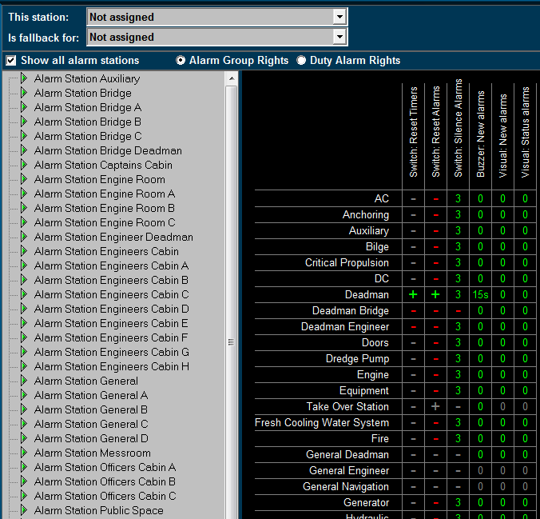

Figure 9‑1: Station Matrix

As you can see the default settings are already in place. Things you cannot do are protected and will show a grey line. Additional settings that are allowed are shown with a red line.

#### This station

Defines the station this computer is set on. All the alarm settings of that station are also valid for the PC screen you are working on. If set to “Not Assigned” no specific alarm restriction is set. All alarms will be visible and can be silenced or acknowledged.

#### Is fallback for

This defines which rights this computer will get once the station set in this box is not working. If this would be the wheelhouse pc it could be a fallback station for the engine room. When the engine room pc should be out for whatever reason, the wheelhouse station will take over the tasks and rights of the engine room pc. This way all the important tasks can still be handled.

#### Show all alarm stations

Ticking this box switches between showing all, or all available Alarmstations.

#### Alarm group rights/Duty alarm rights

Choose either of these two to switch between changing alarm group rights or duty alarm rights.

#### Adjustments

On the left pane you can choose the alarm station to be adjusted. The adjustments will only be valid for that particular station. When you choose to set this station (i.e. Alarm station bridge) on an alarm panel or another Server or client, these will have the same settings automatically.

*:*

*All the settings in the diverse alarm stations will automatically be synchronized to all the other pc’s (servers and clients) which are connected. You won’t have to change all PC’s separately. On the left panel you will find all the groups that are available in the system.   
Groups that are in use by the system are shown in the right pane. Other groups will not be available. You can set the alarm options for each separate group.*

*When finished, all alarm options of each alarm group will be set within the specific alarm stations.*

The following options are available for Alarm Group Rights:

|  |  |
| --- | --- |
| **Alarm group option** | **Explanation** |
| Visual: status alarms | Shows any alarm even if it is acknowledged |
| Visual: new alarms | Shows new alarms for this group |
| Buzzer: new alarms | Sounds buzzer on new alarms for this group |
| Switch: silence alarms | Allows to silence the alarms for this group |
| Switch: reset alarms | Allows to acknowledge the alarms for this group |
| Switch: reset timers | Allows resetting of timers (i.e. dead man’s timer) |

Table 9‑1: Alarm Group Rights

#### How to set Alarm Group Rights

Fields are set separately by pointing the mouse onto that field and right click it. The “Reset” fields will turn to “+” and the other fields will turn to “0” which simultaneously means that the delay is set to “0” minutes.

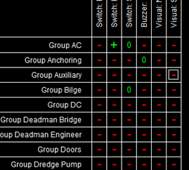

If you want to set a field to a higher delay (i.e. you want to silence an alarm for 3 minutes) you must left click the field. A menu will appear where you can change the settings including the delay time. Check “Enable the selected cells” and choose a delay time. You can choose the delay time in minutes or seconds by checking the appropriate box (seeFigure 9‑2).

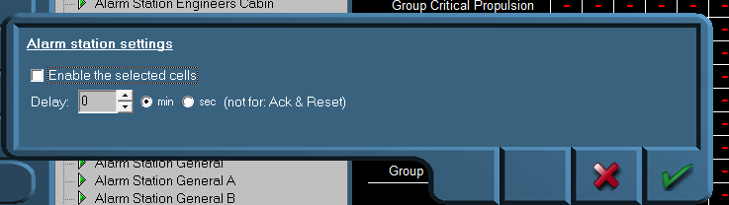

Figure 9‑2: Alarm station settings

In addition, you can do this for different cells at the same time, by clicking and dragging the mouse over the preferred cells (see Figure 9‑3).

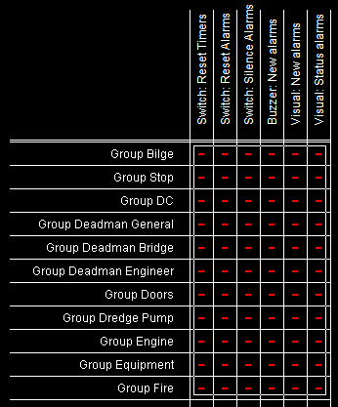

Figure 9‑3: Select by dragging

If you want to disable the alarm settings, deselect the checkbox “Enable the selected cells”.

The following options are available for Duty Alarm Rights:

|  |  |
| --- | --- |
| **Alarm group option** | **Explanation** |
| Call Allowed | Marks if other stations are allowed to call this station |
| Bridge Duty | Marks if station can be selected for Bridge Duty |
| Bridge Duty Select | Marks if station can select bridge duty |
| ER Duty | Marks if station can be selected for ER Duty |
| ER Duty Select | Marks if station can select ER duty |
| Activate station | Marks if station is allowed to switch on or off |

Table 9‑2: Duty Alarm Rights

The “Call Allowed” and “Duty” is shown in the alarm mimic on the main workstations (see Figure 9‑4 and Figure 9‑5).

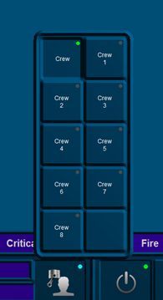

Figure 9‑4: Duty Select function

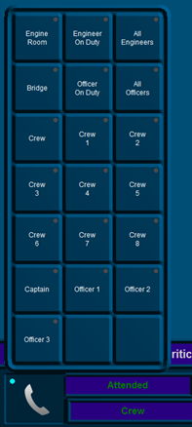

Figure 9‑5: Call Select function

*: The FT NavVision© fields for call and duty select can be found under Field Settings/Alarm/Crew/Crew Alarms.*

## Background

To elaborate a little bit further we will explain a bit more about the use of alarm stations. Each station will be in a particular part of the ship (i.e. wheelhouse, engine room, crewmess, chief engineer cabin etc.) All these stations have their own rights on which alarms they can hear or see and how they can act upon such an alarm. For example, the engine room is the place where all the alarms normally will be visible and almost always the only place where alarms can be acknowledged. This is because regulations require that alarms can only be acknowledged on that part of the ship where you can act upon the alarm and take precautionary action on that alarm. Now in the crewmess (a public space) all kind of people have access to the workstation. It is not advisable that these people have rights to acknowledge the alarm. So in this space you can set the Alarmstation rights for the crewmess, so that they don’t have the rights to acknowledge.

You can imagine that in the wheelhouse they do not want to see all the alarms concerning propulsion etc. merely navigational alarms are mostly enough on the bridge. Here you can set the alarm stations to only show navigational alarms and not propulsion alarms.

# Appendix I

## Rules concerning Deadman Systems

In this chapter a short explanation will be given of the rules and regulations concerning a Deadman system.

## BNWAS or Bridge Deadman

### Scope

The purpose of a bridge navigational watch alarm system (BNWAS) is to monitor bridge

activity and detect operator disability which could lead to marine accidents. The system

monitors the awareness of the Officer of the Watch (OOW) and automatically alerts the Master or another qualified OOW if for any reason the OOW becomes incapable of performing the OOW duties. This purpose is achieved by a series of indications and alarms to alert first the OOW and, if he is not responding, then to alert the Master or another qualified OOW.

Additionally, the BNWAS may provide the OOW with a means of calling for immediate

assistance if required. The BNWAS should be operational whenever the ship’s heading or track control system is engaged, unless inhibited by the Master.

### The BNWAS should incorporate the following operational modes:

* Automatic (Automatically brought into operation whenever the ships heading or track control system is activated and inhibited when this system is not activated)
* Manual ON (In operation constantly)
* Manual OFF (Does not operate under any circumstances)

### Operational sequence of indications and alarms

#### Operational State

Once operational, the alarm system should remain dormant for a period of between 3

and 12 min. At the end of this dormant period, the alarm system should initiate a visual indication on the bridge.

If not reset, the BNWAS should additionally sound a first stage audible alarm on the bridge 15 seconds after the visual indication is initiated.

If not reset, the BNWAS should additionally sound a second stage remote audible alarm in the back-up officer and/or Master location 15 seconds after the first stage audible alarm is initiated.

If not reset, the BNWAS should additionally sound a third stage remote audible alarm

at the locations of further crew members capable of taking corrective actions 90 s after the

second stage remote audible alarm is initiated.

In vessels other than passenger vessels, the second or third stage remote audible alarms may sound in all the above locations at the same time. If the second stage audible alarm is sounded in this way, the third stage alarm may be omitted.

In larger vessels, the delay between the second and third stage alarms may be set to a longer value on installation, up to a maximum of 3 min, to allow sufficient time for the back-up officer and/or Master to reach the bridge.

#### Reset function

It should not be possible to initiate the reset function or cancel any audible alarm from any device, equipment or system not physically located in areas of the bridge providing proper look out. The reset function should only be available in positions on the bridge giving proper look out and preferably adjacent to visual indications. Means of activating the reset function should be easily accessible from the conning position, the workstation for navigating and maneuvering, the workstation for monitoring and the bridge wings.

The reset function should, by a single operator action, cancel the visual indication and all audible alarms and initiate a further dormant period. If the reset function is activated before the end of the dormant period, the period should be re-initiated to run for its full duration from the time of the reset.

To initiate the reset function, an input representing a single operator action by the OOW is required. This input may be generated by reset devices forming an integral part of the BNWAS or by external inputs from other equipment capable of registering physical activity and mental alertness of the OOW.

A continuous activation of any reset device should not prolong the dormant period or cause a suppression of the sequence of indications and alarms.

#### Emergency call facility

Means may be provided on the bridge to immediately activate the second, and subsequently third, stage remote audible alarms by means of an Emergency Call push button or similar.

#### Security

The means of selecting the Operational Mode and the duration of the Dormant Period should be security protected so that access to these controls should be restricted to the Master only.

#### Malfunction

If a malfunction of, or power supply failure to, the BNWAS is detected, this should be indicated. Means shall be provided to allow the repeat of this indication on a central alarm panel if fitted.

## Engineer Deadman

### Scope

The purpose of an Engineer Deadman System is to monitor engine room activity and detect engineer disability which could lead to marine accidents. The system monitors the awareness of the “engineer on duty” and automatically alerts another qualified engineer if for any reason the “engineer on duty” becomes incapable of performing the “engineer on duty” duties. This purpose is achieved by a series of indications and alarms to alert first the

“engineer on duty” and, if he is not responding, then to alert another qualified engineer by means of a general alarm.

Additionally, the Engineer Deadman System may provide the “engineer on duty” with a means of calling for immediate assistance if required. The Engineer Deadman System should be operational whenever the engine room is attended/manned, unless inhibited by the Chief Engineer.

### The Engineer Deadman System should incorporate the following operational modes:

* Manual ON (In operation when engine room is attended)
* Manual OFF (Does not operate under any circumstances)

### Operational sequence of indications and alarms

#### Operational State

Once operational, the alarm system should remain dormant for a period of 30 minutes. At the end of this dormant period, the alarm system should initiate a visual and audio indication on the AMS.

#### Reset function

It should not be possible to initiate the reset function or cancel any audible alarm from any device, equipment or system not physically located in areas of the engine room or ECR (local silence is allowed)

The reset function should only be available in positions in the engine room and ECR. Activating the reset function should be easily accessible from the anywhere in the engine room.

The reset function should, by a single operator action, cancel the visual indication and all audible alarms and initiate a further dormant period. If the reset function is activated before the end of the dormant period, the period should be re-initiated to run for its full duration from

the time of the reset.

To initiate the reset function, an input representing a single operator action by the “engineer on duty” is required. This input may be generated by reset devices forming an integral part of the Engineer Deadman System or by external inputs from other equipment capable of registering physical activity and mental alertness of the “engineer on duty”.

A continuous activation of any reset device should not prolong the dormant period or cause a suppression of the sequence of indications and alarms.

#### Emergency call facility

Means may be provided in the engine room to immediately activate the visual and audible alarm by means of an Emergency Call push button or similar.

#### Security

The means of selecting the Operational should be security protected so that access to these controls should be restricted to the Chief engineer only.

#### Malfunction

If a malfunction of, or power supply failure to, the Engineer Deadman System is detected, this should be indicated. Means shall be provided to allow the repeat of this indication on a central alarm panel if fitted.